Fltterning json data 8

Dataset 8= emp_details_7

[

{

"id":"101",

"name":"srinivas",

"gender":"male",

"languages":["English","Hindi"],

"address":{

            "city":"Hyderabad",

            "country":"india"

          }

},

{

"id":"102",

"name":"phani",

"gender":"male",

"languages":["English","Hindi"],

"address":{

            "city":"Hyderabad",

            "country":"india"

          }

}

]

Here we have flattern both language as well as address

1. Create source created same as previously
2. Now select flattern
3. Go to flattern->unroll by->languages

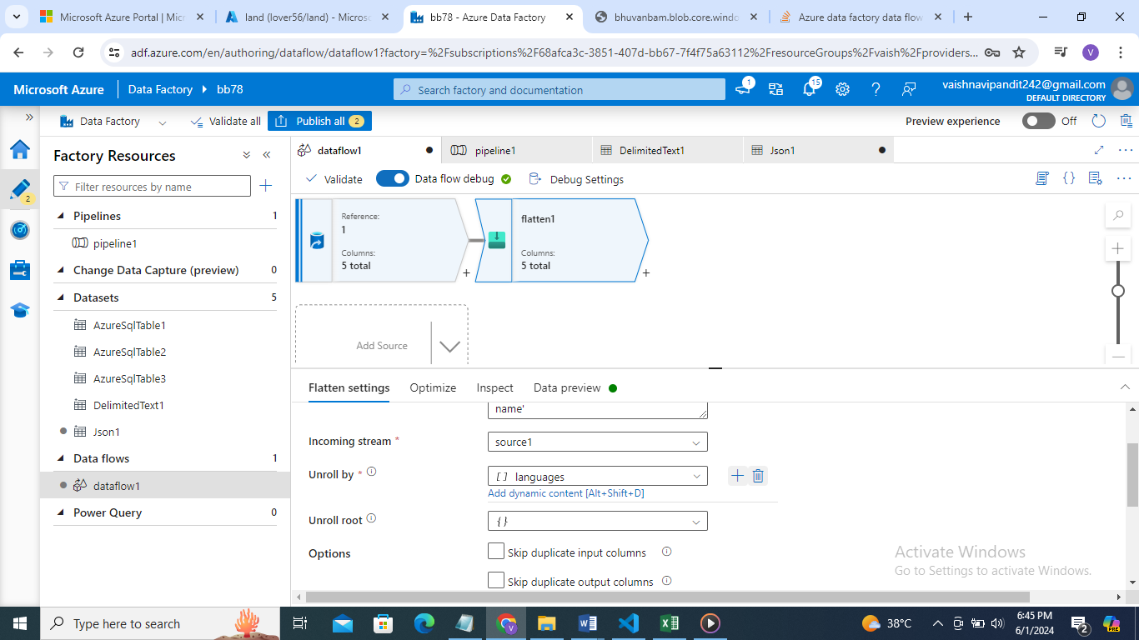

1. Now go to columns click on downward arrow in address you will see address .city select that and as name add city

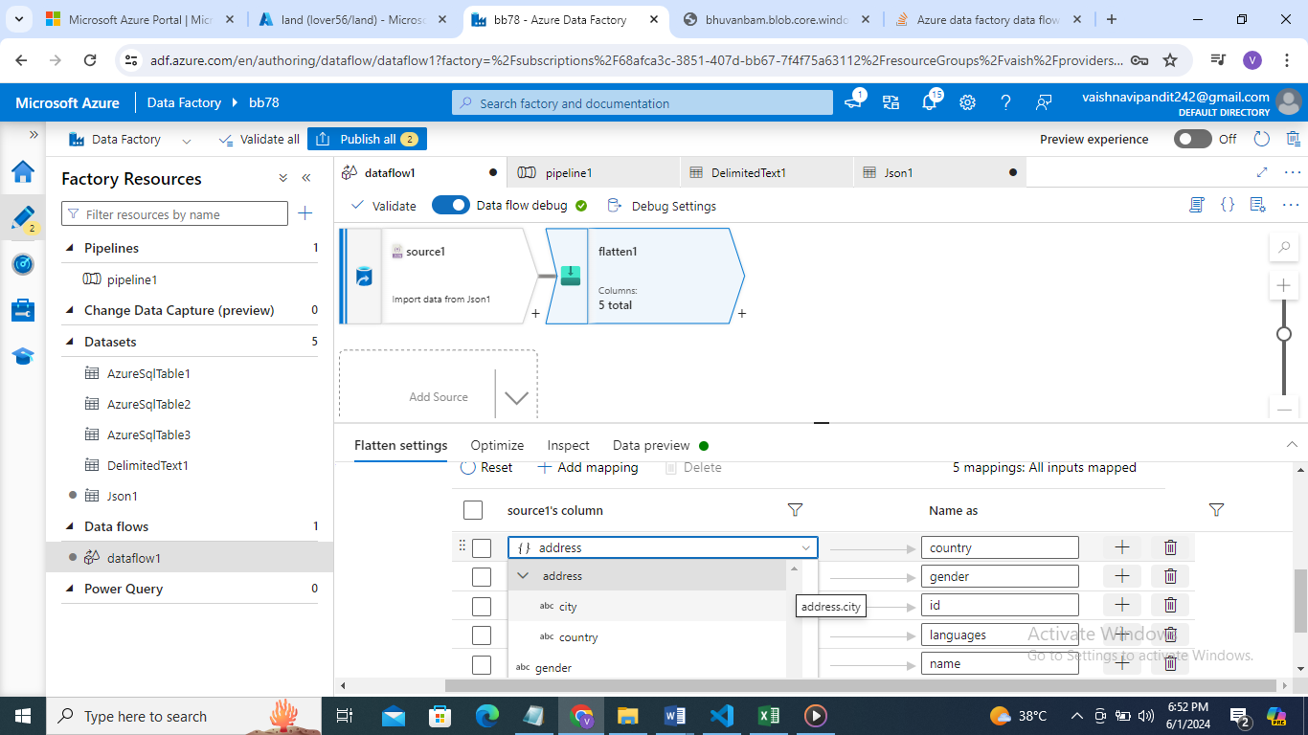

1. Now click on plus besides address

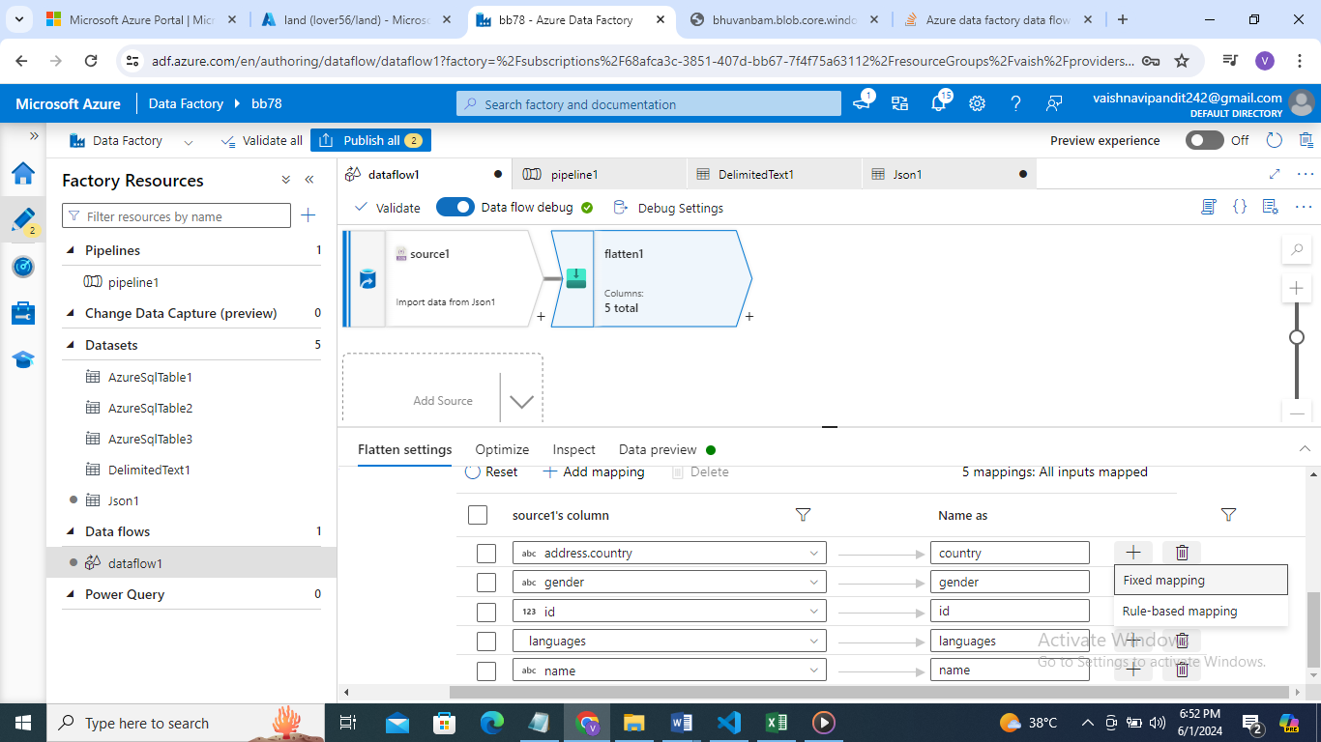

1. Select fixed mapping

Now similarly add addrss.country

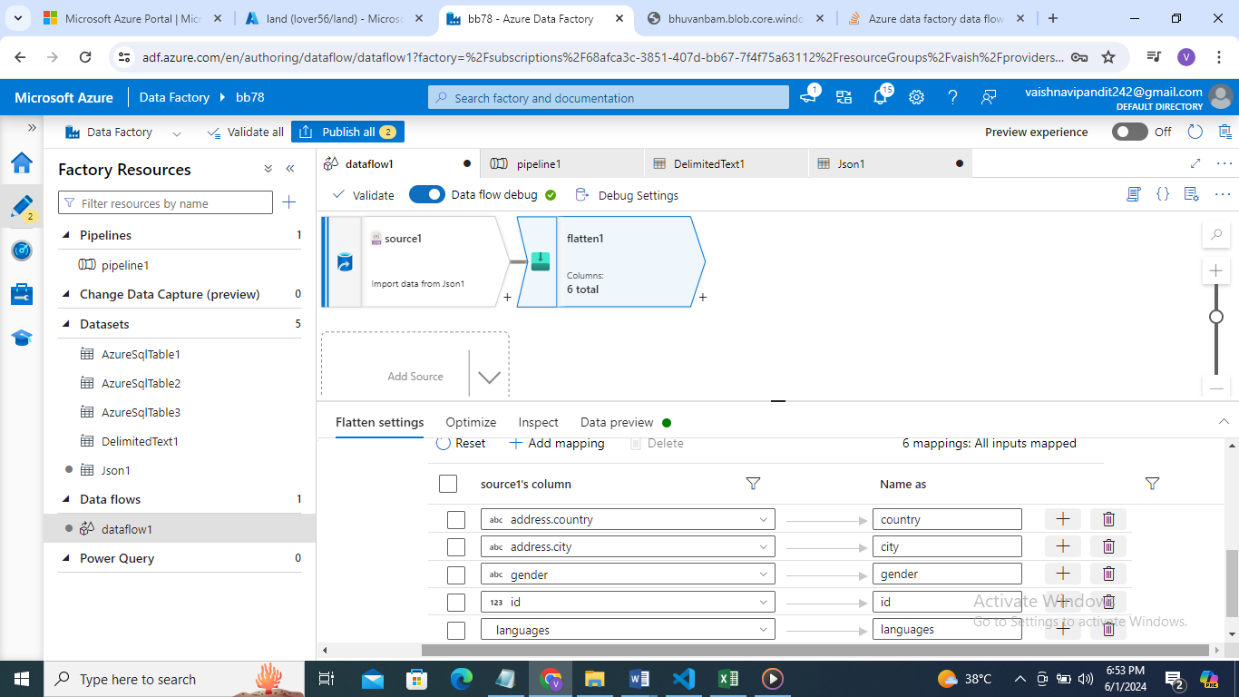

1. Go see preview

